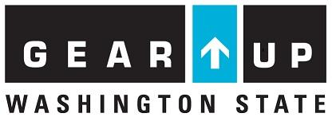
FOCUS GO BIG! Leadership Camp Application
June 25-26, 2018

Name:____________________________________ Student ID_________________________

1. Why are you interested in attending the FOCUS GO BIG! Leadership Camp?

2. What does leadership mean to you?

6. What are your strengths? (not only academic!)

7. What extra-curricular activities are you involved with? (clubs, sports, arts, etc)

Please obtain two staff or teacher recommendations: print/sign/date

1._________________________ ___________________________ ______________
Print Staff Name Signature Date

Why would you recommend this student for a leadership workshop? _________________________________________ ______________________________________________________________________________________________________________________________________________________________________________________________________________________________

2._________________________ ___________________________ ________________
Print Staff Name Signature Date

Why would you recommend this student for a leadership workshop? _________________________________________ ______________________________________________________________________________________________________________________________________________________________________________________________________________________________

Parent Signature: Date:

Student Signature: Date:

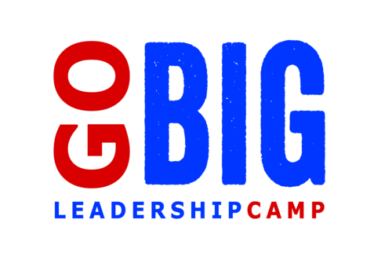
“Camp was the best. I learned not to give up on myself. Friends and teamwork can take you a long way.” — GEAR UP Student

The GO BIG Leadership Camps are high-energy programs that bring middle school students together for a 2-day experience designed to prepare them for the transition into high school. Through our proven experiential learning activities, trained facilitators will help your students with character building, personal leadership skills, and grasping the value of education. GO BIG Leadership Camp will take place at Hudson’s Bay High School this year, giving students an opportunity to spend 2 full days on a high school campus.
GEAR UP Vancouver is offering this opportunity to students at Discovery, Gaiser, and McLoughlin FREE of charge. Students must complete an application, including 2 staff/teacher recommendations. Space is limited to a total of 60 students. Return application to your GEAR UP staff by May 1, 2018.
Date: June 25 and June 26, 2018
Time: 9:00-3:30 pm each day
Location: Hudson’s Bay High School
FOCUS Training will:
- Design and facilitate daily programming
- Teach middle school students to set goals, communicate effectively, and more
- Facilitate an outdoor challenge course
- Provide fun activities
- Include a community service component
- Lunch and snacks will be provided both days
- Camp will be supervised by GEAR UP staff and FOCUS Camp Facilitators

